**1.Write a HTML program to demonstrate all types of list in HTML.**

<!DOCTYPE html>

<html>

<head>

<h1>Types of list in html</h1>

<p>Unordered list</p>

</head>

<body>

<ul style="list-style-type:none;">

<li>CSE</li>

<li>IT</li>

<li>EE</li>

</ul>

<hr>

<p>Ordered List</p>

<ol type="i">

<li>WEB TECHNOLOGY</li>

<li>DBMS</li>

<li>DAA</li>

</ol>

<hr>

<p>Description List</p>

<dl>

<dt>DAA</dt>

<dd>- Design and analysis of algorithm</dd>

<dt>DBMS</dt>

<dd>- Database management system</dd>

</dl>

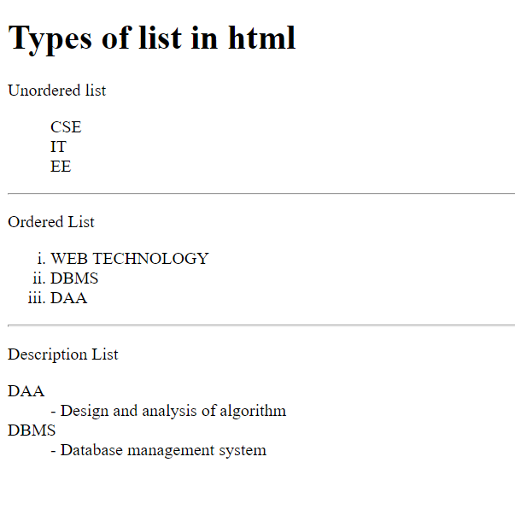

<body/>

**2. Write a HTML page that includes an image a hyperlink, moving text and table.**

<!DOCTYPE html>

<html>

<head>

<h1>Including an Image</h1>

<body>

<img src=https://www.google.co.in/url?sa=i&rct=j&q=&esrc=s&source=images&cd=&ved=2ahUKEwjkusuU_P3lAhWkyDgGHbhaDaQQjRx6BAgBEAQ&url=https%3A%2F%2Fwww.pexels.com%2Fsearch%2Fsky%2F&psig=AOvVaw3yK6ou3jiM_0N8MZA3R4j7&ust=1574517298509484

67636.jpeg?auto=compress&cs=tinysrgb&dpr=1&w=500" alt="Italian Trulli">

</body>

<h1>Including an Hyper link</h1>

<body>

<a href="url">link text</a>

</body>

<h1>Including a moving text</h1>

<body>

<marquee>TEXT</marquee>

</body>

<h1>Table</h1>

<body>

<table style="width:100%">

<tr>

<th>Firstname</th>

<th>Lastname</th>

<th>Age</th>

</tr>

<tr>

<td>Jill</td>

<td>Smith</td>

<td>50</td>

</tr>

<tr>

<td>Eve</td>

<td>Jackson</td>

<td>94</td>

</tr>

</table>

</body>

</head>

</html>



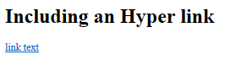





**3.Create a registration form with the following fields:**

* **Name as text field**
* **Password as password field**
* **Email as text field**
* **Phone no: as text field**
* **Gender as radio button**
* **DOB using 3 select boxes**
* **Languages known as check boxes**
* **Address as text area**
* **Submit and reset button**

<!DOCTYPE html>

<html>

<head>

<h1>Registration Form</h1>

</head>

<style>

.container{

text-align: center;

border: 2px solid black;

font-family: Arial;

font-size: 18px;

padding: 2px 2px 2px 2px;

height: 100%;

width: 35%;

background-color: powderblue;

}

#name, #email, #psw, #psw-repeat, #phone, #gender, #date, #lanuages, #address, #dateofbirth{

display: grid;

grid-template-columns: 1fr 1fr;

grid-gap: 5px;

padding: 0px 0px 10px 0px;

}

</style>

<body>

<form action="action_page.php">

<div class="container">

<h1>Register</h1>

<p>Please fill in this form to create an account.</p>

<hr>

<div id="name">

<label for="name"><b>Name</b></label>

<input type="text" placeholder="Enter your name" name="name" required>

</div>

<div id="email">

<label for="email"><b>Email</b></label>

<input type="text" placeholder="Enter Email" name="email" required>

</div>

<div id="psw">

<label for="psw"><b>Password</b></label>

<input type="password" placeholder="Enter Password" name="psw" required>

</div>

<div id="psw-repeat">

<label for="psw-repeat"><b>Repeat Password</b></label> <input type="password" placeholder="Repeat Password" name="psw-repeat" required>

</div>

<div id="phone">

<label for="phone"><b>Mobile no:</b></label>

<input type="text" placeholder="Enter your phone number" name="phone" required>

</div>

<hr>

<div id="gender">

<label for="gender"><b>Gender</b>

<ul>

<li><input type="radio" name="Male">Male</li>

<li><input type="radio" name="Female">Female</li>

<li><input type="radio" name="Other">Other</li>

</ul>

</label>

</div>

<div id="dateofbirth">

<label for="date"><b>Date</b>

<select name="DOBDay">

<option value="1">1</option>

<option value="2">2</option>

<option value="3">3</option>

<option value="4">4</option>

<option value="5">5</option>

<option value="6">6</option>

<option value="7">7</option>

<option value="8">8</option>

<option value="9">9</option>

<option value="10">10</option>

<option value="11">11</option>

<option value="12">12</option>

<option value="13">13</option>

<option value="14">14</option>

<option value="15">15</option>

<option value="16">16</option>

<option value="17">17</option>

<option value="18">18</option>

<option value="19">19</option>

<option value="20">20</option>

<option value="21">21</option>

<option value="22">22</option>

<option value="23">23</option>

<option value="24">24</option>

<option value="25">25</option>

<option value="26">26</option>

<option value="27">27</option>

<option value="28">28</option>

<option value="29">29</option>

<option value="30">30</option>

<option value="31">31</option>

</select>

<select name="DOBMonth">

<option value="January">January</option>

<option value="February">February</option>

<option value="March">March</option>

<option value="April">April</option>

<option value="May">May</option>

<option value="June">June</option>

<option value="July">July</option>

<option value="August">August</option>

<option value="September">September</option>

<option value="October">October</option>

<option value="November">November</option>

<option value="December">December</option>

</select>

<select name="DOBYear">

<option value="1995">1995</option>

<option value="1996">1996</option>

<option value="1997">1997</option>

<option value="1998">1998</option>

<option value="1999">1999</option>

<option value="2000">2000</option>

<option value="2001">2001</option>

<option value="2002">2002</option>

<option value="2003">2003</option>

<option value="2004">2004</option>

<option value="2005">2005</option>

<option value="2006">2006</option>

<option value="2007">2007</option>

<option value="2008">2008</option>

<option value="2009">2009</option>

<option value="2010">2010</option>

</select>

</label>

</div>

<hr>

<div id="languages">

<label for="languages">Languages Known

<ul>

<li><input type="checkbox" name="Hindi">Hindi</li>

<li><input type="checkbox" name="English">English</li>

</ul>

</label>

</div>

<div id="address">

<label for="address">Address

<ul>

<li><textarea rows='4' cols='25'>Enter your address

</textarea></li>

</ul>

</label>

</div>

<hr>

<p>By creating an account you agree to our <a href="#">Terms & Privacy</a>.</p>

<button type="submit" class="registerbtn">Submit</button>

<button type="Reset" class="submitbtn">Reset</button>

<p>Already have an account? <a href="#">Sign in</a>.</p>

</div>

</form>

</body>

</html>

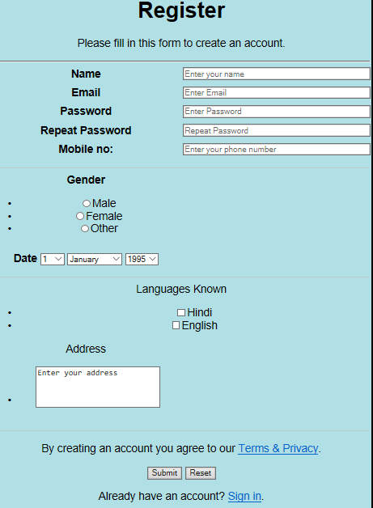

**4.Design a webpage using html and css the webpage include two headline fields and one paragraph and make a separate style sheet where you define the following style properties that are to be applied to the selectors:**

* **Color**
* **Font-family**
* **Font-size**
* **Text-decoration**

**Then in the body of your webpage refer the style sheet to activate the style on your webpage.**

<!DOCTYPE html>

<html>

<style>

h1{

color: black;

font-family: Serif;

font-size: 24px;

text-decoration: overline;

}

h2{

color: black;

font-family: Sans-serif;

font-size: 20px;

text-decoration: underline;

}

p{

color: solid black;

font-family: Monospace;

font-size: 18px;

text-decoration: underline overline;

}

</style>

<head>

<h1>The first heading in html</h1><br>

<h2>The second heading in html</h2><br>

<p>Paragraph in html</p>

</head>

</html>

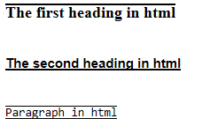

**5.Write an XML file which will display the following information for book:**

* **Title of the book**
* **Author name**
* **ISBN no:**
* **Publisher’s name**
* **Edition**
* **Price**

**Also write DTD rules and XML schema to validate this file**

**DTD**

<?xml version="1.0"?>  
<!DOCTYPE note SYSTEM "note.dtd">

<!Element Book (title, author, isbn, publisher, edition, price)>

<!Element title (#PCDATA)>

<!Element author (#PCDATA)>

<!Element isbn (#PCDATA)>

<!Element publisher (#PCDATA)>

<!Element edition (#PCDATA)>

<!Element price (#PCDATA)>

**XML Schema**

<?xml version="1.0"?>  
<xs:schema xmlns:xs="http://www.w3.org/2001/XMLSchema"  
targetNamespace="https://www.w3schools.com"  
xmlns="https://www.w3schools.com"  
elementFormDefault="qualified">

<element name = “catalog”>

<complexType>

<sequence>

<element name = “Book” minoccurence = “1” maxoccurence = “10”>

<complexType>

<sequence>

<element name = “title” type = “string”/>

<element name = “author” type = “string”/>

<element name = “isbn” type = “integer”/>

<element name = “publisher” type = “string”/>

<element name = “edition” type = “string”/>

<element name = “price” type = “integer”/>

</sequence>

</complexType>

</element>

</sequence>

</complexType>

</element>

</schema>

**XML Document**

<catalog>

<Book>

<title>Harry Potter and the Goblet of Fire</title>

<author>JK Rowling</author>

<isbn>9783161484100</isbn>

<publisher>Rowling</publisher>

<edition>3rd edition</edition>

<price>520</price>

</Book>

<Book>

<title>Harry Potter and the Chamber of Secrets </title>

<author>JK Rowling</author>

<isbn>9780136019701</isbn>

<publisher>Rowling</publisher>

<edition>5th edition</edition>

<price>470</price>

</Book>

</catalog>

**6. Write the JS code to change the BG color of the paragraph on mouse over event and the color changes to previous event on mouse out event.**

<!DOCTYPE html>

<html>

<head>

</head>

<style>

#abc{

font-size: 26px;

text-align: center;

}

</style>

<body>

<script>

function affect()

{

var x = document.getElementById("abc");

x.style.backgroundColor = "red";

}

function reverseaffect()

{

var x = document.getElementById("abc");

x.style.backgroundColor = "blue";

}

</script>

<p id = "abc" onmouseover = "affect()" onmouseout = "reverseaffect()" > paragraph</p>

</body>

</html>

Before mouse



Figure

After on mouse event



**7. Write a javascript program to demonstrate all types of pop-up boxes**

* **Alert**
* **Confirm**
* **prompt**

<!DOCTYPE html>

<html>

<head>

<title>Program_6</title>

<meta charset="UTF-8">

</head>

<body>

<h1>JavaScript Pop-up boxes</h1>

<button onclick="myFunction1()"> Try the alert pop-up </button><br><br>

<button onclick="myFunction2()"> Try the confirm pop-up </button><br><br>

<button onclick="myFunction3()"> Try the prompt pop-up </button>

<p id="demo"></p>

<script>

function myFunction1() {

alert("I am an alert box!");

}

function myFunction2() {

var txt;

if (confirm("Press a button!")) {

txt = "You pressed OK!";

} else {

txt = "You pressed Cancel!";

}

document.getElementById("demo").innerHTML = txt;

}

function myFunction3() {

var txt;

var person = prompt("Please enter your name:", "Harry Potter");

if (person == null || person == "") {

txt = "User cancelled the prompt.";

} else {

txt = "Hello " + person + "! How are you today?";

}

document.getElementById("demo").innerHTML = txt;

}

</script>

</body>

</html>

**OUTPUT**

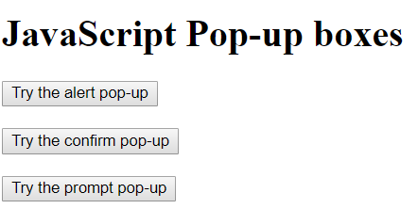

**When alert box appears**

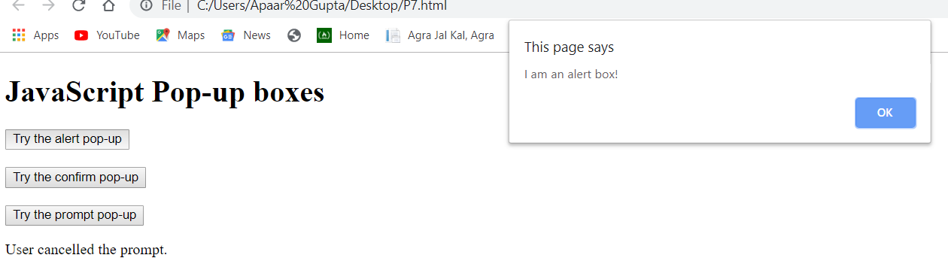

**When confirm box appears: click on ok button**

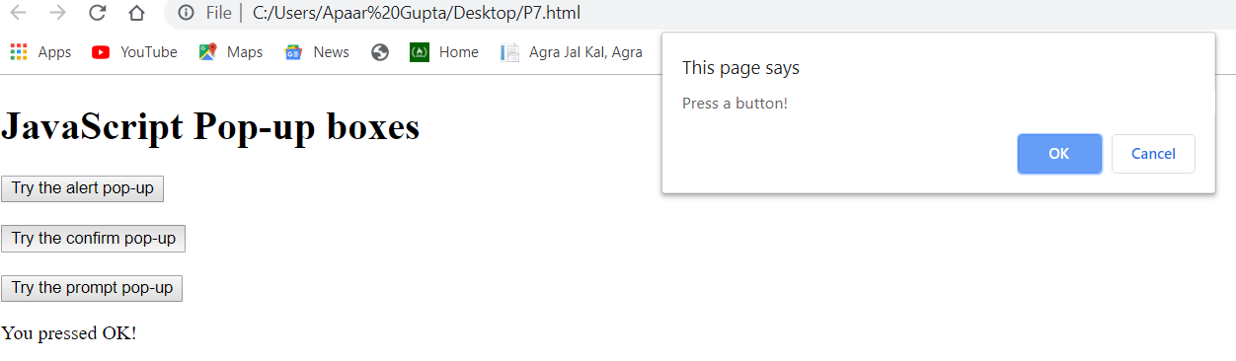

**When confirm box appears:click on cancel button**

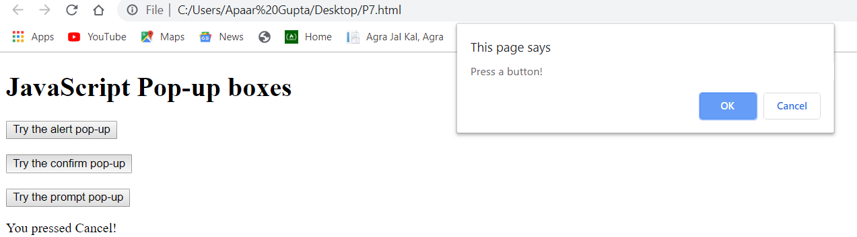

**When prompt box appears:click on ok button**

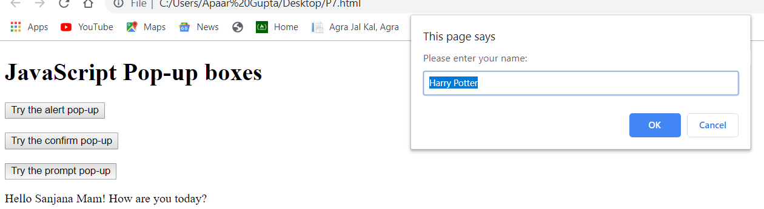

**When prompt box appears: click on cancel button**

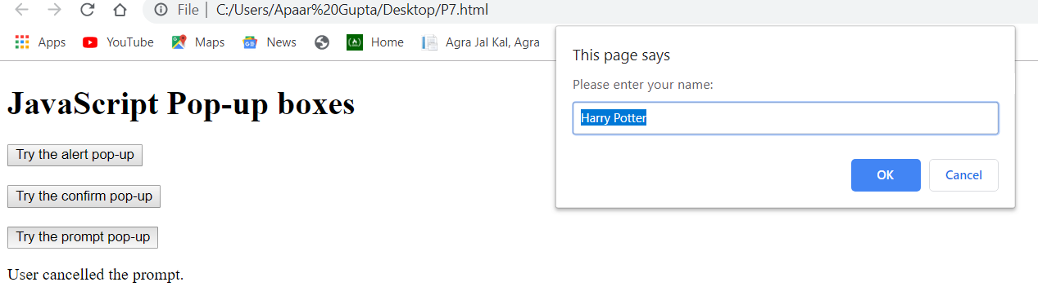

**8. Write a JS program to change the content of the program on the click of a button.**

<!DOCTYPE html>

<html>

<head>

</head>

<style>

#abc{

font-size: "26px";

text-align: center;

}

button{

position: absolute;

margin-left: 50%;

}

</style>

<body>

<script>

function affect()

{

var x = document.getElementById("abc");

x.innerHTML = "This is inner paragraph";

}

</script>

<p id = "abc">Just a paragraph</p>

<button onclick="affect()">Click</button>

</body>

</html>

Before Clicking:



After clicking:

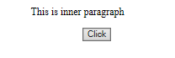

**9. Write a JS code to validate a form for empty fields.**

<!DOCTYPE html>

<html>

<head>

<h1>Validate form for empty fields</h1>

</head>

<script>

function validate()

{

var uname = document.getElementById("uname");

var password = document.getElementById("pass");

if(uname.value == "")

{

alert("Blank username");

return false;

}

else if(password.value == "")

{

alert("Blank password");

return false;

}

else if(password.value.length<5)

{

alert("Too short");

return false;

}

else

{

return true;

}

}

</script>

<body>

<form onsubmit = "return validate();" action = "________">

username<input type = "text" id = "uname"/><br>

password<input type = "password" id = "pass"/><br>

<button type = "submit">Login</button>

</form>

</body>

</html>

When username field is empty.

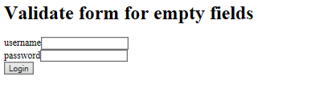

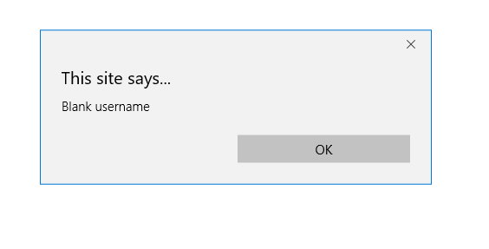

When username and password are filled.

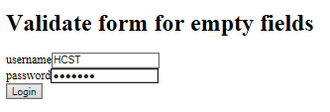

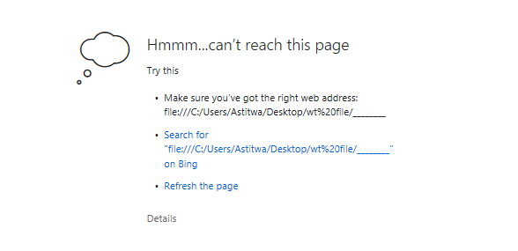

**10.Write a program in javascript to validate a mobile number for blank field as well as for regular expressions**

<!DOCTYPE html>

<head>

<title>Mobile Validation</title>

</head>

<script>

function validate()

{

var email = document.getElementById("text").value;

var regx = /^[6-9]\d{9}$/;

if(regx.test(email))

{

document.getElementById("lbl").innerHTML = "Valid";

document.getElementById("lbl").style.visibility = "visible";

document.getElementById("lbl").style.color = "green";

return true;

}

else

{

document.getElementById("lbl").innerHTML = "Invalid";

document.getElementById("lbl").style.visibility = "visible";

document.getElementById("lbl").style.color = "red";

return false;

}

}

</script>

<body>

<form action = "________" onsubmit = "return validate()">

<input id = "text" type = "text"/>Mob no::

<label id = "lbl" style = "color: red; visibility: hidden;">Invalid no:</label>

<input type = "submit" value = "submit">

</form>

</body>

When mobile number is invalid



When mobile number is invalid



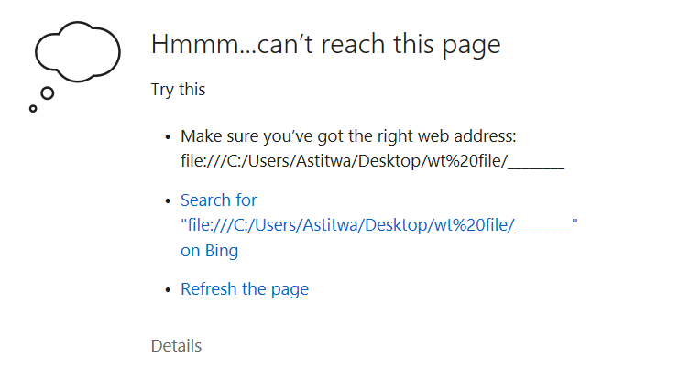

**11. Write a regular expression for an email also write a javascript code to validate email ids against this regular expression.**

<!DOCTYPE html>

<head>

<title>Email Validation</title>

</head>

<script>

function validate()

{

var email = document.getElementById("text").value;

var regx = /^([a-zA-Z0-9_\.\-])+\@(([a-zA-Z0-9\-])+\.)+([a-zA-Z0-9]{2,4})+$/;

if(regx.test(email))

{

document.getElementById("lbl").innerHTML = "Valid";

document.getElementById("lbl").style.visibility = "visible";

document.getElementById("lbl").style.color = "green";

return true;

}

else

{

document.getElementById("lbl").innerHTML = "Invalid";

document.getElementById("lbl").style.visibility = "visible";

document.getElementById("lbl").style.color = "red";

return false;

}

}

</script>

<body>

<form action = "________" onsubmit = "return validate()">

<input id = "text" type = "text"/>Email id:

<label id = "lbl" style = "color: red; visibility: hidden;">Invalid no:</label>

<input type = "submit" value = "submit">

</form>

</body>

When email is invalid



When email is valid

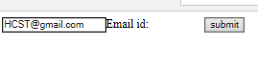

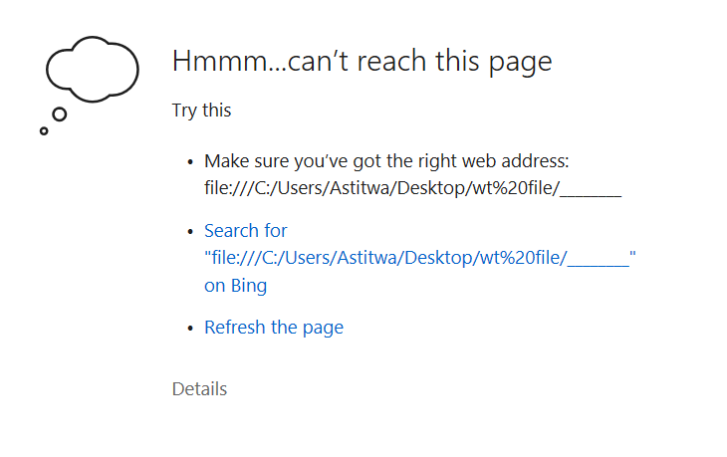

**12. Write the JS code to detect and display a browser information.**

<!DOCTYPE html>

<html>

<head>

</head>

<p id="demo"></p>

<script>

document.getElementById("demo").innerHTML =

"cookiesEnabled is " + navigator.cookieEnabled;

</script>

